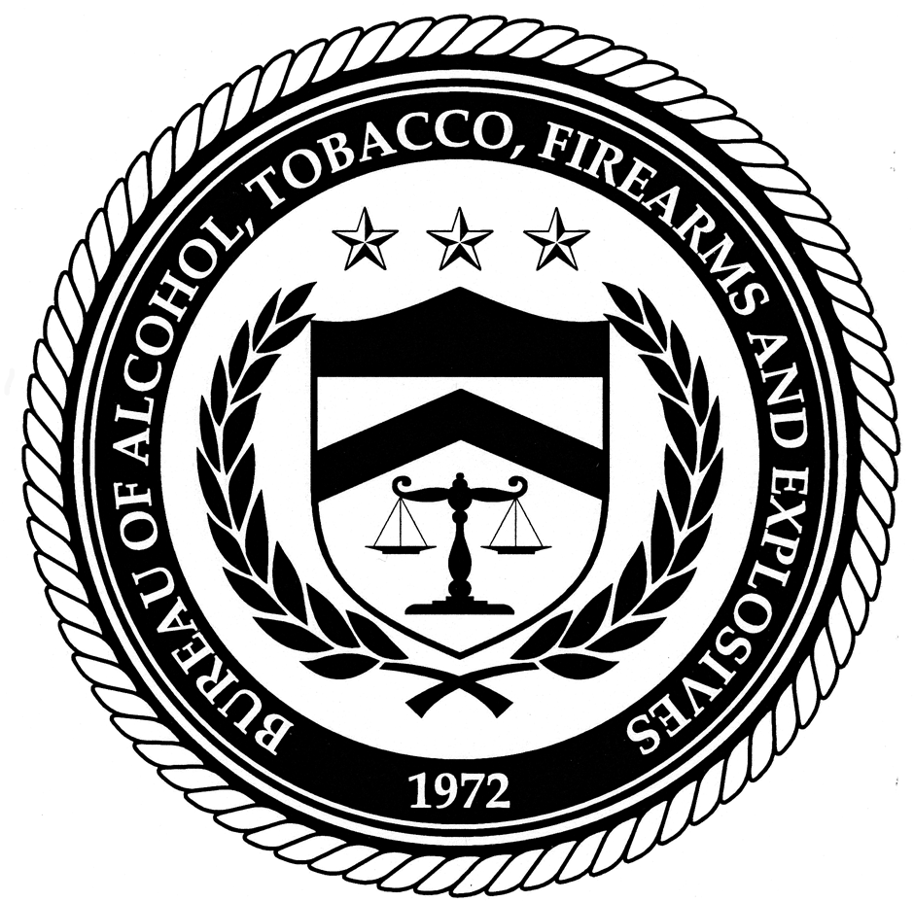 | U.S. Department of Justice  Bureau of Alcohol, Tobacco,  Firearms and Explosives
 | Washington, DC 20226
 | www.atf.gov

August 25, 2006

Dear Users Congress Members,

Thank you for your time in Largo, Florida last week. I hope you all made it back safely. As discussed during the conference, all Users will have to take Security Awareness Training. NIBIN is asking for you to please inform all of the Users in your region of this mandate and the Security Awareness Training. Your help in this matter will be greatly appreciated.

The Bureau of Alcohol, Tobacco, Firearms and Explosives (ATF) as a Federal agency is subject to Federal mandates, including the Federal Information Security Management Act (FISMA) of 2002. This Act requires that ATF provide information security awareness training to all ATF employees, task force members, and contractors concerning their security responsibilities when they use an ATF information network. User and support personnel of the National Integrated Ballistic Information Network (NIBIN) including Forensic Technology (FT) personnel must complete this mandated training.
The ATF Information Security Awareness Training is an annual requirement and is available online at www.learnATF.gov. Students have 60-days from the activation of their LearnATF accounts to complete the training. Students that fail to complete their training within a 60-day timeframe will have their NIBIN accounts disabled, and notifications will be sent to ATF and FT management to address their training issues in a timely manner. Access to the system will not be granted until the training is complete. If your NIBIN account is disabled it can be re-enabled by calling the NIBIN Help Desk, however, the training requirement will not be voided. More information will be available concerning this training on the NIBIN website: http://www.nibin.gov/
LearnATF accounts will be activated on September 5, 2006--meaning that all users must complete their training requirement no later than November 6, 2006,to avoid having their NIBIN accounts disabled. Please find attached the Security Awareness Training Guide.
Please contact Karen Molina (NIBIN Program Analyst) for more information, questions or concerns: 240-264-1434.

Regards,

Steven Pugmire
NIBIN Branch

