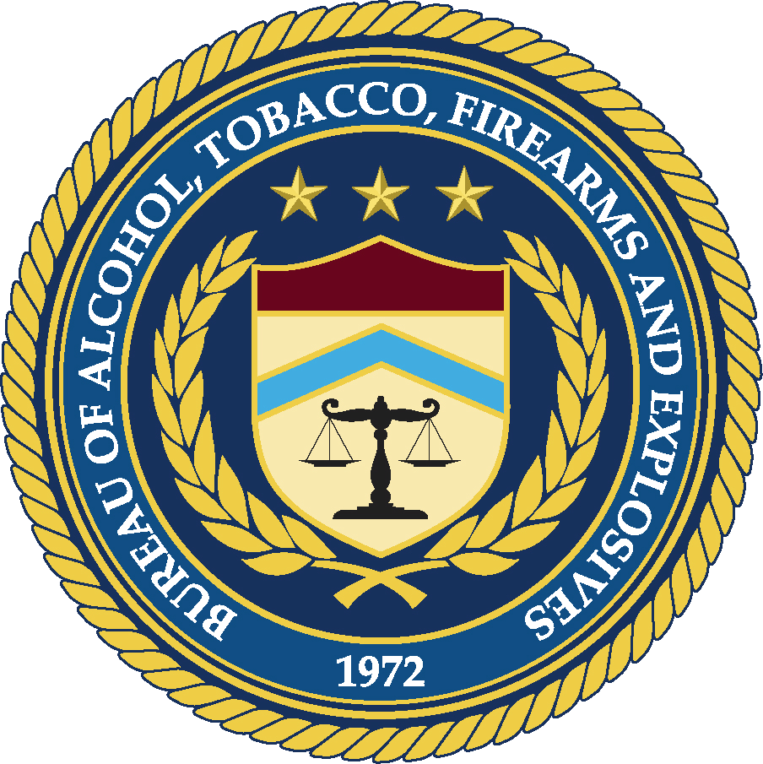
Attending IBIS Training:
ATF National Integrated Ballistic Information Network
IBIS Training-Information Bulletin
January 2010

HOTEL:
The NIBIN Program has obtained a block of rooms for each training week at the following hotel:
Holiday Inn Hotel & Suites Harbourside
401 Second Street
Indian Rocks Beach, Florida 33785
Phone Number: (800) 726-0865
Website: www.hiharbourside.com
When calling for your reservations, please identify that you are obtaining rooms reserved with ATF. All rooms are guaranteed at the government rate, are priced for single/double occupancy only, and based upon availability, can be upgraded to Studio Rooms at time of check-in. All rooms have 2 Queen beds, mini-refrigerator, and data port phone. Our training contractor, Forensic Technology, Inc., will provide shuttle services between the hotel and training facility. The shuttle service leaves the front of the hotel promptly each morning at 7:45 a.m. The hotel is across from the beach, has two pools, a marina, and is within walking distance of several restaurants. You will be within walking distance of a trolley service that travels the entire Gulf Beach. It is advised that you contact the hotel for your reservations as soon as possible.

MEALS:
The IBIS/FTI training center in Largo, Florida does not have restaurants conveniently close by. In order to facilitate meal times during training, catering services have been arranged. While at training, catered lunch will be provided, and each student will be asked to contribute $33.00 per person/per week for the cost of the food. On Monday of each training week, a fee of $33.00 will be collected by the receptionist at FTI.

If you are a vegetarian or have any food allergies, please notify Celine Desmarais by fax (514-485-9336) or e-mail (Celine.Desmarais@contactft.com) at your earliest convenience and they will ask the Caterer to adjust your menu accordingly. A weekly menu is attached for your reference.

Additionally, a complimentary continental breakfast is provided each morning for class attendees at the hotel.

TRANSPORTATION:
It is recommended that you use the Tampa airport shuttle, The Limo Super Shuttle 727-572-1111, or www.supershuttle.com, which costs $25.00 one-way or $50.00 roundtrip, when purchased in advance. The Super shuttle can be picked up at either end of the baggage claim area on the outside of the airport. Once at training, please call a day in advance to arrange for your return trip to the airport.

If you have any questions, please contact ATF IBIS Specialist, Niki M. McCall at 404-417-2733.

