 Pre-course Material and Documentation

This letter will be the guiding document for your Data Acquisition training to become proficient in the entry of cartridge casings into IBIS and correlation review. Its scope is comprehensive in that it:

- a. Explains the format of the course

b. Defines the topics to be addressed

c. Defines the standards for successful completion

Beyond the actual course content are some concerns that should seize your attention, primarily relating to motivation and attitude. You should bear in mind that your laboratory has selected you for this training. You should take full advantage of the opportunity presented by the course to become an effective, contributing user.

Course Goal

The purpose of the course is to provide specialized Integrated Ballistics Identification System (IBIS) training for individuals, such as yourself, selected by your laboratory. Upon successful completion of this training, you should be able to independently and competently enter cartridge casings into IBIS and perform correlation review.

Course Standards and User Progress

ATF staff will be on-site to instruct and evaluate your progress concerning your assignments and competency testing. Note that the following policies will be in effect:

- a. Student must be present for all days of training.

- b. Student must participate in all assigned ATF and FTI activities and exercises.

c. Student must take and successfully pass the assigned cartridge case competency test.

d. Failure of a competency test will result in immediate remedial training and re-test. Failure of the re-test will result in access denial to the IBIS system and the NIBIN network.

e. Students are expected to maintain a high level of professional conduct and integrity at all times during their association with the ATF sponsored training.

Instruction Phases

The Data Entry Instruction is divided into two (2) phases, which will be detailed below.

Phase 1

During the pre-instruction phase, you will have received documents describing instruction information, user expectations, computer, and basic firearm skills questionnaires.

Phase 2

This phase is the actual instruction given at an on-site location. This structured phase will include demonstrations, a competency test, and practical applications of IBIS Data Acquisition techniques you will learn. This hands-on experience is the core of your training and will provide you with a sound foundation for continuing development at your agency’s laboratory.

Competency Testing

Competency tests consist of a cartridge casing, which will be acquired after the instructional module has been completed. Each student will be required to participate in the competency testing phase. To successfully pass the competency test, you must acquire quality images according to protocol; and the correlation results must return the Known Match case within the top ten correlation values for cartridge casing either by Breechface, Firing Pin or Ejector.

IBIS Data Acquisition Instructional Outline

Instruction Description:
The IBIS Data Acquisition instruction is designed for Crime Laboratory Technicians and Firearms Examiners who want to learn how to acquire cartridge case images using the IBIS system.

Target Audience:
The course is intended for two audiences: Crime Laboratory Technicians and Firearms Examiners who have never used the IBIS system.

Instruction Prerequisites:
- • Basic computer skills (Windows environment)
- • Basic firearms knowledge

Computer Skills Questionnaire

The following is a list of computer-related terms. Check the box next to each term if you are familiar with its meaning:

Database □ Server □ Username □
On-line Help □   Input fields □ Cursor □
Logging On □   Shortcut Keys □ Tool Bar □
Hard Drive □  WAN □ Desktop □
Application □  Windows □ LAN □
Data Backup □ Monitor □ Menus □ 

The following is a list of computer-related tasks. Check the box next to each task if you feel able to complete unassisted:

Log on to a computer workstation   □
Use an application’s On-line Help system to get assistance in completing a task □ 
Use the keyboard to: type information into fields   □
update/edit information in fields □  
perform specialized tasks using key combinations such as Ctrl+Alt+Delete to close an application □ 
Use the mouse to: open and close dialog boxes and windows □  
  scroll up and down windows and lists □  
  select items on the screen, such as text, buttons and icons □  
  navigate through menus to choose commands □ 
  right-click to view menus or activate special commands □  

1. Identify the marketer of the cartridge (a) and the caliber (b) from the following headstamp information.

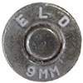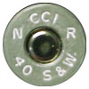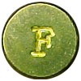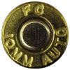
a.___________ a.___________ a.__________ a.__________
b.___________ b.___________ b.__________ b.__________

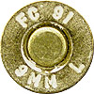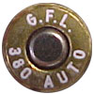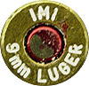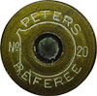

a.___________ a.___________ a.__________ a.__________
b.___________ b.___________ b.__________ b.__________

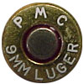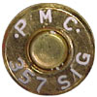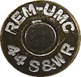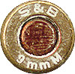
a.___________ a.___________ a.__________ a.__________
b.___________ b.___________ b.__________ b.__________

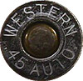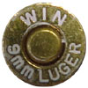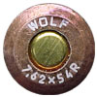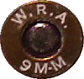
a.___________ a.___________ a.__________ a.__________
b.___________ b.___________ b.__________ b.__________

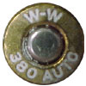
a.___________
b.___________

2. During your training, you will be entering cartridge case exhibit(s) into IBIS. The firing pin shape is a mandatory field and is crucial to the correlation process; it is therefore important that the correct firing pin shape is identified and entered in IBIS. The three basic center fire firing pin shapes are circular, Glock type and rectangular. Enclosed with the pre-course material is an IBIS Image Acquisition Standards document for your use as a resource.

Identify the firing pin shapes of the following images.
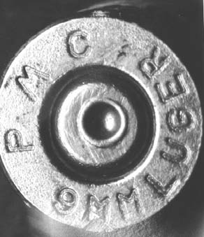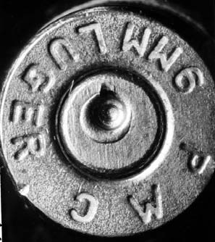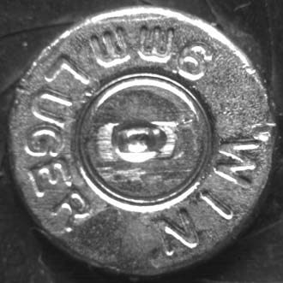

a._______________ b._________________ c.___________________

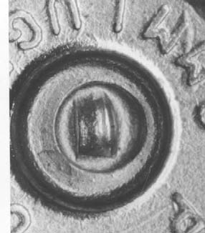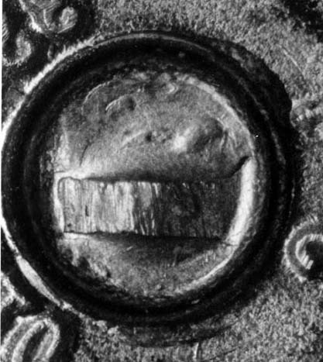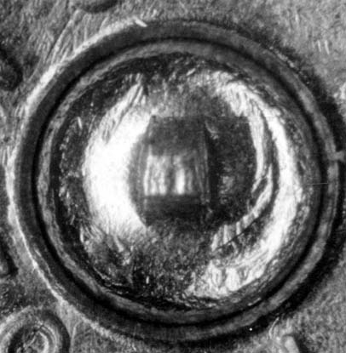

d._______________ e._________________ f.___________________
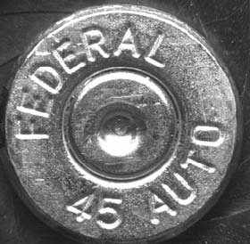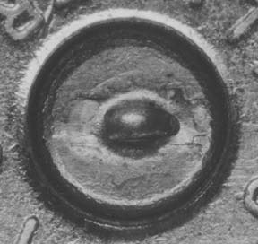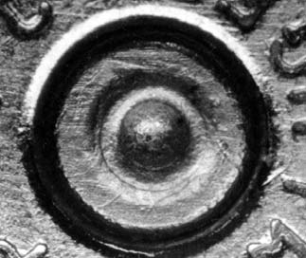

g._______________ h._________________ i.___________________

3. Breech Face Marks are categorized by the following descriptions (e.g. parallel, arc, crosshatch, circular, granular, and smooth), identify the following breech face marks.

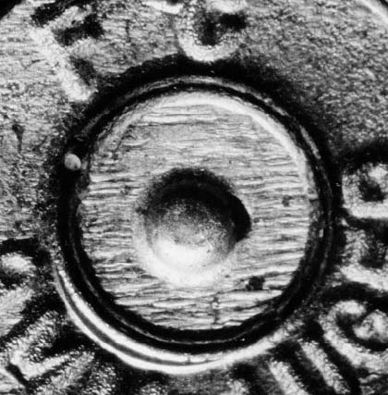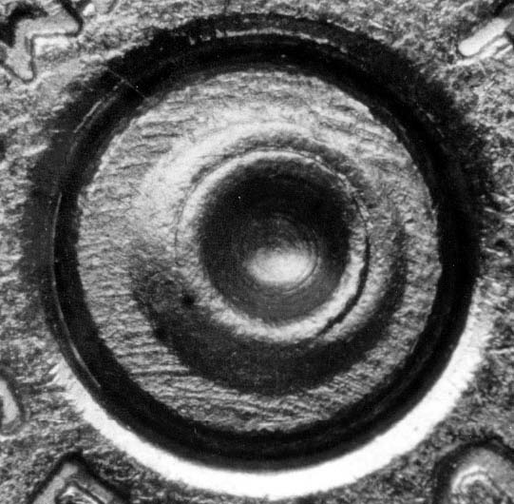

a. ______________________________ b. _______________________________

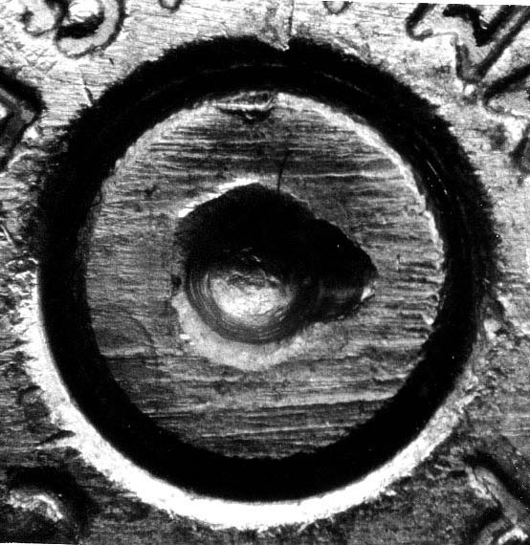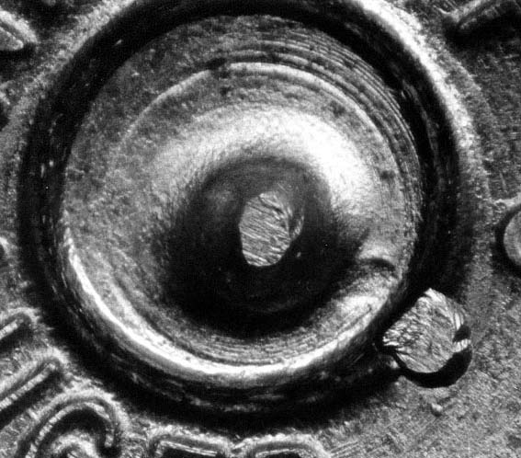

c. _______________________________ d. _____________________________________

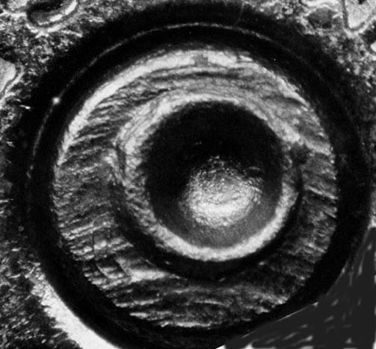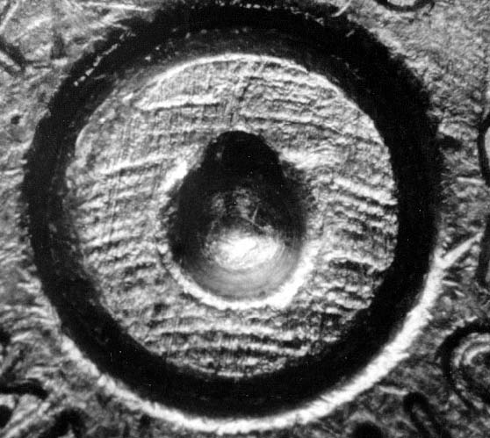

e. _________________________________ f. __________________________________

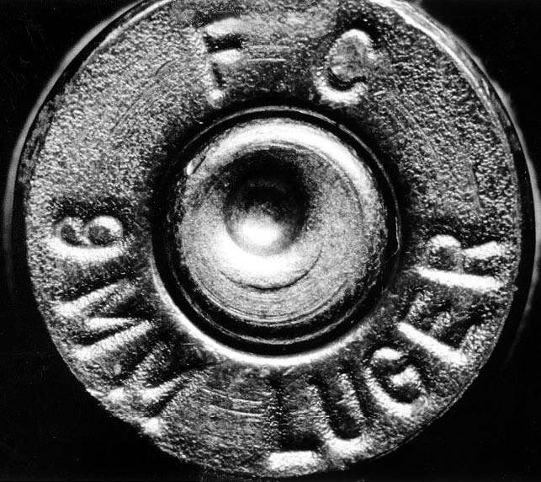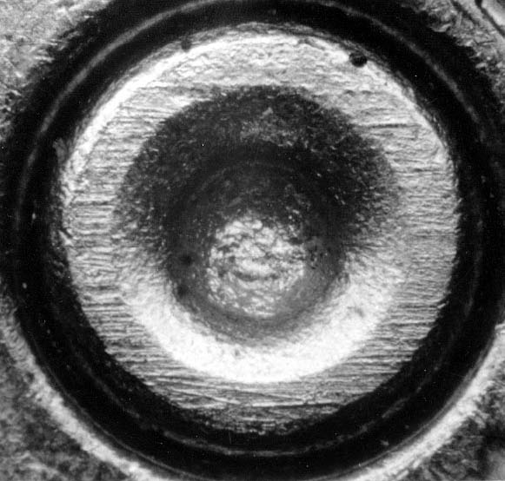

g. _____________________________________ h. ___________________________________

Student background information:

Name (print): _____________________________________________________________________

Title:____________________________________________________________________________

Agency: _________________________________________________________________________

Address:_________________________________________________________________________

Telephone: _______________________________________________________________________

Email Address: ____________________________________________________________________

How many years of firearms experience? ________

Do you perform forensic cartridge casing and bullet comparisons? ___________________________

If you answer “no” to the above question, is there a firearm examiner available on-site for technical consultation? ______________

Are you assigned to a unit that supports NIBIN? ________________________________

Does your agency employ you full-time? (If no, explain below) _______________________________

Explanation (e.g., detail, part-time, PSN grant): ___________________________________________

Approximately what percentage of your time will support NIBIN data entry? ___________________

Name and location of NIBIN site where you will enter data? _________________________________

Who will review correlation results for data entered by you? _________________________________

Related training and occupational experience: __________________________________________________________________________________________________________________________________________________________________________

NIBIN User Certification

I have read all the attached documents and understand what will be expected of me. I agree to exert my best efforts in accomplishing the assignments set out during all phases of the IBIS Data Acquisition Instruction.

__________________________ __________________
NIBIN User Signature Date

Supervisor Concurrence

__________________________ __________________
Supervisor Signature Date

